Name: Chenxin Shen

Batch Code: LISUM35

Submission Date: August 5th, 2024

Submitted to: Week 5: Cloud and API deployment

1. Create model and run to obtain pickle file (and also check saved model works)

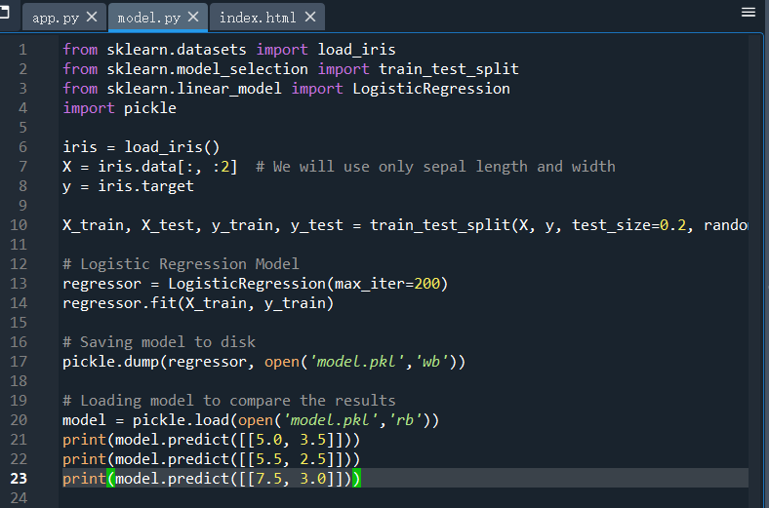

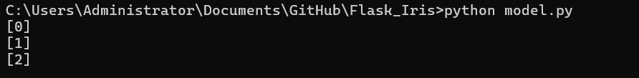

1. Create HTML template

1. Create Flask website and run it

1. Create app on Heroku

1. Connect Github repository to the app

1. Deploy the main branch

1. I think I ran into a problem because I do not have a plan. I will try to do this on some other platforms.